Laboratory work：lab4
Student: FangJiahui
Student ID: 24320124
Timus Name:hduads2026_24320124
Mail: 3892551687@qq.com
Problem:1521，1650
Screenshot from Timus:
1521：
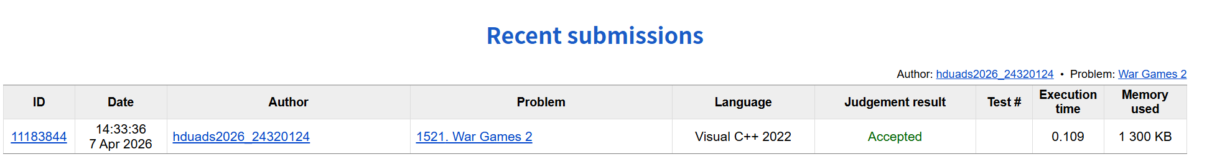
1620：

Explanation of algorithm:
1521：
The Fenwick tree maintains whether each position has a soldier (1 for present, 0 for eliminated).
findKth(k) finds the k-th remaining soldier in O(log N) time.
After finding the soldier to eliminate, remove it from the tree (update to 0).
Update the next search position using the formula:
pos = (pos - 1 + K - 1) % (remaining - 1) + 1
Each elimination takes O(log N) time, giving a total time complexity of O(N log N).

1620：

Computational complexity of algorithm:
1521：
Time Complexity: O(N log N)
Each of the N eliminations requires O(log N) time (find + update).
Space Complexity: O(N)
The Fenwick tree and result array each require O(N) space.

1620：

Source code:
1521：
#include <iostream>
#include <vector>
using namespace std;

int N, K;
struct Fenwick {
int n;
vector<int> bit;

Fenwick(int n) : n(n), bit(n + 1, 0) {}

void update(int idx, int delta) {
while (idx <= n) {
bit[idx] += delta;
idx += idx & -idx;
}
}

int query(int idx) {
int res = 0;
while (idx > 0) {
res += bit[idx];
idx -= idx & -idx;
}
return res;
}

int findKth(int k) {
int lo = 1, hi = n;
while (lo < hi) {
int mid = (lo + hi) / 2;
if (query(mid) >= k) hi = mid;
else lo = mid + 1;
}
return lo;
}
};

int main() {
cin >> N >> K;

Fenwick bit(N);
for (int i = 1; i <= N; i++) bit.update(i, 1);

int pos = K;
vector<int> result;

for (int remaining = N; remaining >= 1; remaining--) {
int soldier = bit.findKth(pos);
result.push_back(soldier);
bit.update(soldier, -1);

if (remaining == 1) break;
pos = (pos - 1 + K - 1) % (remaining - 1) + 1;
}

for (int i = 0; i < result.size(); i++) {
if (i > 0) cout << " ";
cout << result[i];
}
cout << endl;

return 0;
}
1620：

